PROJECT
Employee Dataset (Data Analysis)
OBJECTIVE:To analyse employee data stored in a CSV file to understand important details like salaries,departments,experience,performance,etc.and generate meaningful insights for decision -making.
OUTCOMES-The project gives clear insights into data analysis,as we have used various tools and techniques such as calculating the mean,mode and minimum -maximum values using pandas.we have also applied grouping and filtering methods,and visualised the data using Matplotlib through bar charts,line charts and scatter plots.
WORKING-Collab,or “Colaboratory”,allow you to write and execute python in your browser,with whether you’re student,a data scientist or an AI engineer.it allow you to upload files.
STEP1:Upload the CSV File on google Collabaratory for the analysis of data.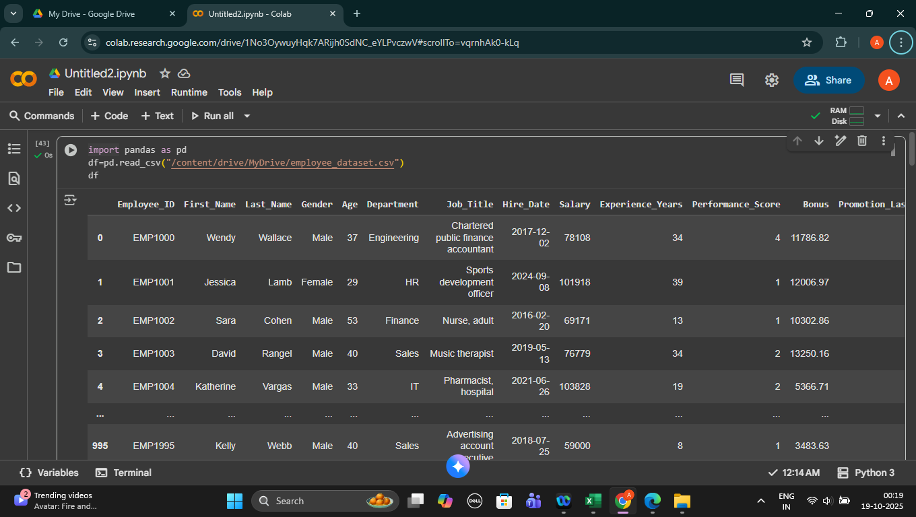
STEP2-write the code to find mean and mode .
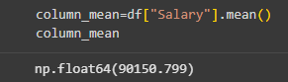
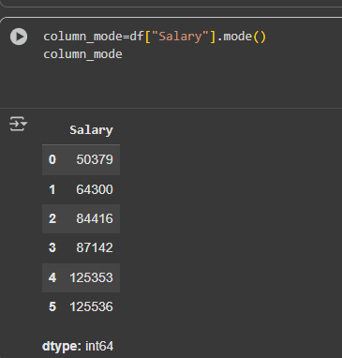
STEP3:Write the code to find minimum and maximum of the given data.
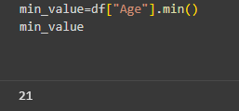
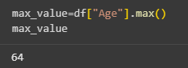
STEP4:Write a code to filter the given data for analysis.
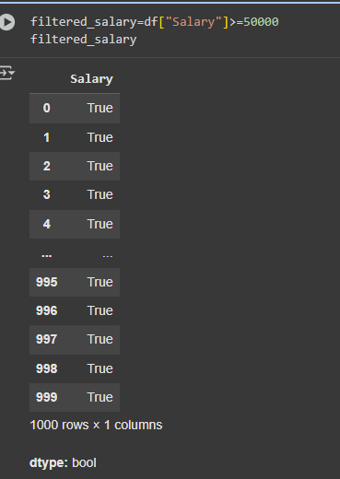

STEP5: Sort the data in descending order.
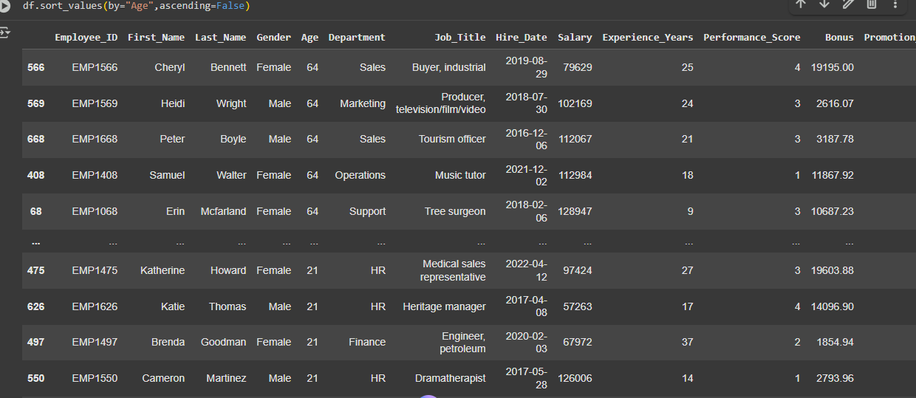
STEP6: Sort the data in ascending order.
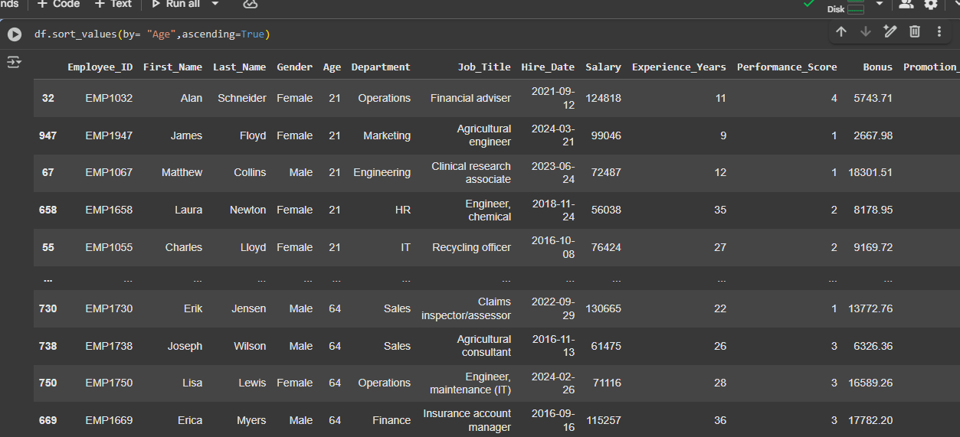
STEP7: Grouping of the given data.
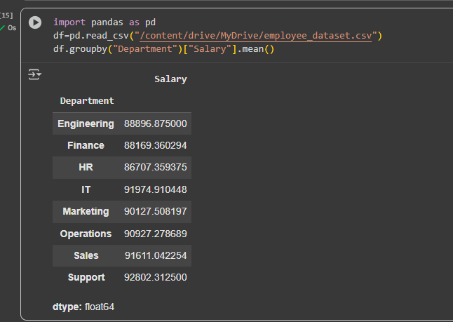
STEP8:Now,import a matplotlib as plot to represent the axis.
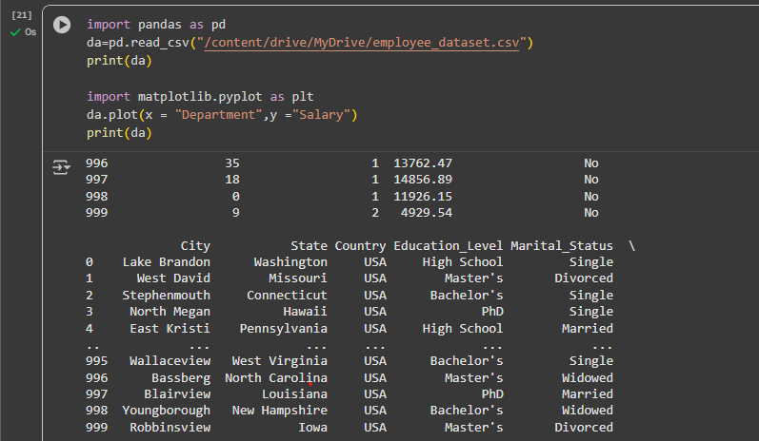
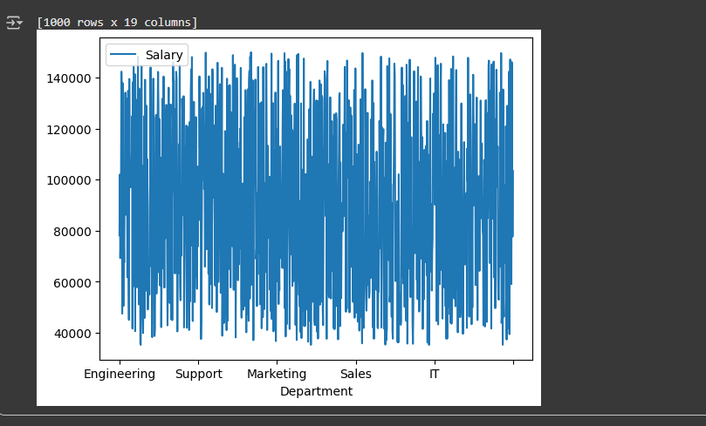
STEP9-Generate a bar,line ,scatter plots to visual monthly revenue.
1.FOR LINE
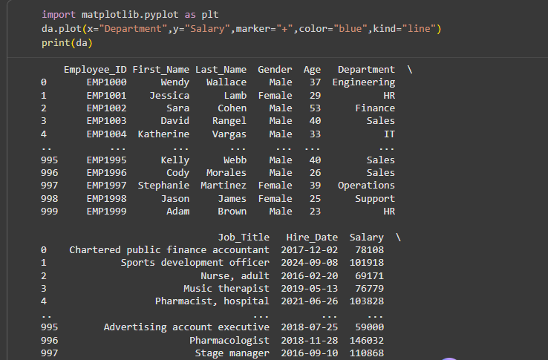
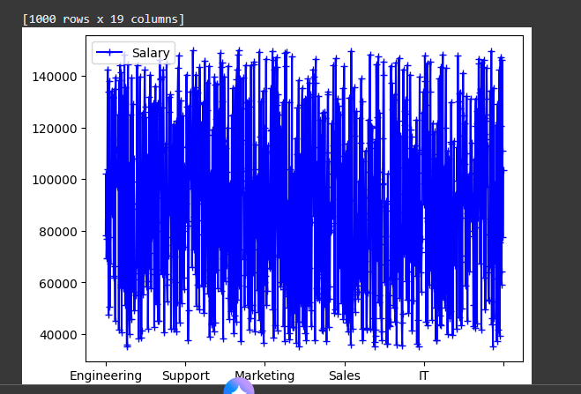
2.FOR SCATTER
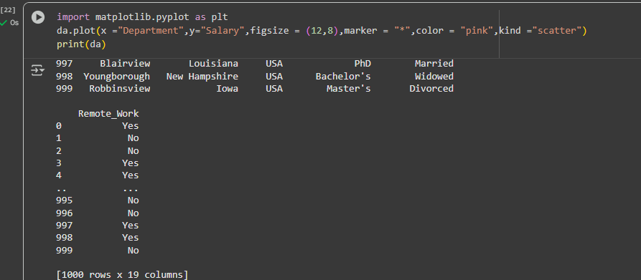

3. FOR BAR
